Technology Integrated Lesson Plan

Overview
Grade 4 – Explanatory/Informative Writing
Research Report

This lesson not only integrates technology, but also Writing and Reading Informational Text Common Core Standards. Prior to the lesson, students are surveyed using Google Forms to gather information as a teacher about topics of interest. After being immersed into the research genre, students use Padlet as a way to collaborate on taking notes. Then, students type their draft using Google Docs so the teacher can provide immediate feedback and suggestions. After finishing the revising and editing stages of writing, students use their expertise about their subject to create mini-documentaries using iMovie. The class celebrates and shares their projects by holding a film festival.

Standards
Writing:
W.4.2: Write informative/explanatory texts to examine a topic and convey ideas and information clearly.
W.4.5: With guidance and support from peers and adults, develop and strengthen writing as needed by planning, revising, and editing. (Editing for conventions should demonstrate command of Language standards)
W.4.6: With some guidance and support from adults, use technology, including the Internet, to produce and publish writing as well as to interact and collaborate with others; demonstrate sufficient command of keyboarding skills to type a minimum of one page in a single sitting.
W.4.7 Conduct short research projects that build knowledge through investigation of different aspects of a topic.
W.4.8: Recall relevant information from experiences or gather relevant information from print and digital sources; take notes and categorize information, and provide a list of sources.
W.4.9: Draw evidence from literary or informational texts to support analysis, reflection, and research.
Language:
L.4.2: Demonstrate command of the conventions of standard English capitalization, punctuation, and spelling when writing.
Reading Informational Text:
RI.4.1: Refer to details and examples in a text when explaining what the text says explicitly and when drawing inferences from the text.
RI.4.2: Determine the main idea of a text and explain how it is supported by key details; summarize the text.
RI.4.4: Determine the meaning of general academic and domain-specific words or phrases in a text relevant to a grade 4 topic or subject area.
RI.4.5: Describe the overall structure (e.g., chronology, comparison, cause/effect, problem/solution) of events, ideas, concepts, or information in a text or part of a text.
RI.4.9: Integrate information from two texts on the same topic in order to write or speak about the subject knowledgeably.
Technology:
ISTE-S 1: Creativity and Innovation
Students demonstrate creative thinking, construct knowledge, and develop innovative products and processes using technology. (iMovie)
a. Apply existing knowledge to generate new ideas, products, or processes
b. Create original works as a means of personal or group expression
ISTE-S 2: Communication and Collaboration
Students use digital media and environments to communicate and work collaboratively, including at a distance, to support individual learning and contribute to the learning of others.
a. Interact, collaborate, and publish with peers, experts, or others employing a variety of digital environments and media
b. Communicate information and ideas effectively to multiple audiences using a variety of media and formats
d. Contribute to project teams to produce original works or solve problems
ISTE-S 3: Research and Information Fluency
Students apply digital tools to gather, evaluate, and use information.
b. Locate, organize, analyze, evaluate, synthesize, and ethically use information from a variety of sources and media
ISTE-S 5: Digital Citizenship
Students understand human, cultural, and societal issues related to technology and practice legal and ethical behavior.
b. Exhibit a positive attitude toward using technology that supports collaboration, learning, and productivity
ISTE-S 6: Digital Citizenship
Students demonstrate a sound understanding of technology concepts, systems, and operations.
a. Understand and use technology systems

Timeframe
3 weeks – during reading and writing
(including all parts of writing process and project)

Materials
- computer lab access (mobile PC carts can be used for all parts except the iMovie final project)
- projector
- iMovie
- book bins with a variety of topics

Lesson Preparation
- Create a survey using Google Forms to assess student interest levels in different subjects. Make sure you have a variety of topics for students to choose from. When creating the survey, be sure to have an item for “name” (using the text item) and then use the “checkboxes” option so students can select more than one interest. (to learn how to create a google form, visit: club157blog.weebly.com and go to the tutorials page)
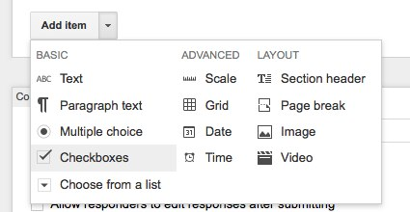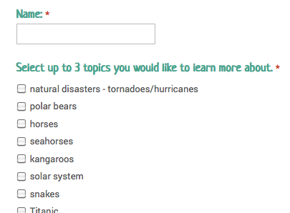
- Look over the responses and determine the topics students were most interested in. Select around 5 topics and create a book basket for each one consisting of a variety of texts at different levels. Put the students in groups based on where their interest was.
- Prepare a Padlet wall for each topic and post the link somewhere easy for students to access. (to learn how to create a wall, visit club157blog.weebly.com and go to the tutorials page)

Lesson Procedures
Immersion
- Read many examples of research reports to students.
- Have students browse and explore research reports.
- During this immersion phase, begin a chart titled, “What makes a research report?”
- As you are reading aloud or after reading a research report, record what the students notice about research reports. Questions could include: “What is the topic?” “How was the information organized (structure)?” “What made the text interesting to the reader?” “What transition words were used from one idea to the next?” “Were other sources of information mentioned?” “What were they?” “Did you hear any unfamiliar words?” “What were they?” Analyze and determine as a group what makes the research report successful in teaching you something new in an interesting way. Continue to chart what the authors did and remind the students that they can do it too!
- Keep charted responses short and meaningful; add illustrations or pictures as necessary.
- Make sure that students know that research reports can be written about anything and seen on a daily basis.

Teacher Modeling (note-taking):
- Teacher walks students through the process of pulling information from a variety of non-fiction resources (both written and electronic).
- Teacher models on Padlet adding a post with a main idea and supporting details.
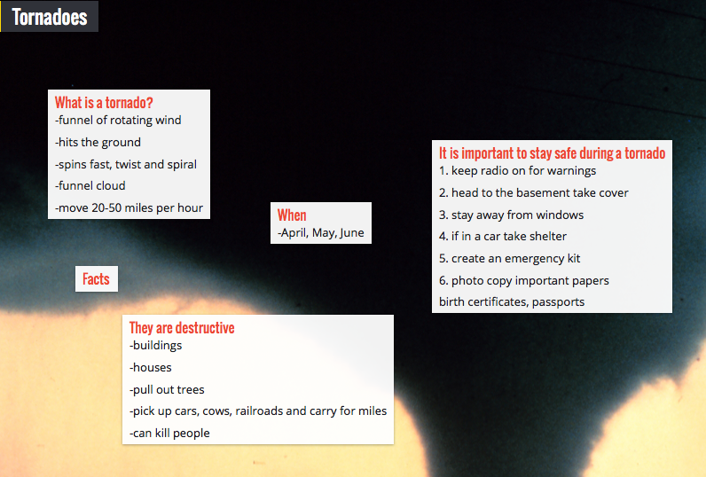
(student example)
- Teacher will model how to pull facts from chosen subtopics or categories.

Student Note-taking Collaboration:
Provide students with access to computers and their book baskets. Direct them to the link to where their Padlet wall is. There is also a tutorial for students on how to edit a Padlet post (club157blog.weebly.com and go to the tutorials page). Allow students to spend time collaborating on gathering notes about their topic.

Teacher Modeling (drafting):
- Show the students how to create a new document in Google Docs if they don’t know how. Demonstrate how to share it with the teacher or move it to an already shared folder.
- Teacher model how to group related facts into a paragraph.
- Teacher makes each main idea a different color to show how they are grouped together.
- Teacher uses transitional words to connect ideas from paragraph to paragraph.
- Make all of your decisions in front of your students. You may say something like this, “Kids, I’m going to be thinking out loud as I develop my research report. I’m doing that so that when you write you’ll know what kind of thinking writers do.”
- Refer to the class chart often so that students see that you are thinking like a writer by noticing what other authors have done, always reinforcing that our subject/topic is kept in mind when creating a research report.

Student Drafting:
Allow students to draft their reports and remind them that good writers get all their ideas down first and then revise and edit.

Public Revising Conferences:
- Celebrate the work and the writer’s strengths.
- Focus on content first.
- Acknowledge the child and the hard work he/she has put into this piece of writing.
- Whole group discussions for making teaching points and having focus lessons (mini-lessons).
- Identify what the writer needs to move forward.
- Revise your writing in front of the students.

Editing:
- Hold students accountable for editing based on expectations you come up with as a class and display somewhere.
- Allow students to share with a peer to edit.

Extension Project
- Have students get in pairs who researched the same topic.
- Show them student examples or professional clips of documentaries.
- Give them time to read each other’s reports and decide what they want to share in their mini-documentary. They should plan out on paper a simple storyboard that shows they have thought about what pictures they need and who is responsible for each part.
- Allow the students to find their pictures (or pre-select images they can choose from to prevent having to search the web). Wikimedia commons is a great resource.
- The best way to organize the pictures is to put them in an iPhoto album, or in a folder on the desktop.
- Model creating an iMovie or direct students to the tutorial (club157blog.weebly.com on the tutorials page)
- Publish the finished movies and share on a class website or hold a class film festival

Evaluation
Students will be assessed on their collaboration on note taking and how well they worked together. The research report will be graded based on the rubric that you and your students create together. It is important to create this together so they have buy-in on doing their best. The final iMovie will also be evaluated on a rubric. Here is an example of a possible movie rubric:
 | 3 - exceptional | 2 - satisfactory | 1 - developing | 0 – not evident
Slides went in a sequential order that makes sense to the viewer.
Content – information shared is accurate and interesting
Text – title, credits, important vocabulary is included
Audio – all speakers are an appropriate volume and speak clearly, music is present, appropriate, and doesn’t overpower movie
Effects – effects don’t overpower presentation, were used to enhance presentation
Teamwork – worked well and independently collaborated, used time wisely

